Evolution Aircraft, Inc.
39440 South Ave.
Zephyrhills, Fl. 33542
www.EvolutionTrikes.com
(813) 810-9262
SERVICE
BULLETIN

Adding an in-line oil supply check valve
SB--‐0001 RELEASED December 12, 2016
Status: Optional

Page 1 of 4
BACKGROUND:
It has been discovered it is possible in some rare cases to start a REVO and not get oil pressure within proper range during the first 5 seconds of the engine starting. Per Rotax, if you do not get oil pressure within 10 seconds, the engine must be shut down in order not to do damage to the motor. Installing the bolt on in-line check valve will help keep the oil pump primed during start up and allow oil pressure to build faster. Regardless of having the new check valve or not, oil pressure must be monitored after start up and confirmed within 10 second, or the engine must be shut down.
SCOPE:
The following serial numbers of REVO weight-shift-control that are affected by this SERVICE Bulletin: 1001-1016 All serial numbers and serial number from 000550 -000620
AUTHORIZED PERSONS:
LSRM OR A&P
Type of Maintenance:
Line maintenance
TOOLS:
- 1” open end wrench
- 15/16” open end wrench
- Teflon tape
- Air compressor with proper tip to pressurize oil system
- Plug device for oil reservoir INLET

Page 2 of 4
COMPLIANCE
Compliance is optional, but highly recommended
How to comply with this bulletin:
- Remove the supply oil line coming from the oil reservoir at the oil thermostat.
- Remove the male fitting from the oil thermostat
- Reinstall that fitting using Teflon tape into the check valve making sure the arrow, showing direction of flow, is pointing away from the fitting
- If not pre installed from the factory, install using Teflon tape the male/male adaptor pipe thread fitting into the other end of the check valve
- Using Teflon tape install the 3 part check valve assembly onto the oil thermostat where the oil supply line was removed
- Install the oil line onto the check valve assembly not: do NOT use Teflon tape on this fitting
- Purge the oil system as per Rotax manual. Note if you are not familiar with this process please look up how to do this procedure in detail or find someone that is familiar to do this. (removing the oil return line at the reservoir and drain into a bucket. Block the oil IN inlet on the oil reservoir and pressurize the system through the reservoir vent line using the compressor and turn the prop in the direction of its natural rotation until oil flows from the open line into the bucket.
- Once oil is flowing through the system and coming out of the open oil line into the bucket, reconnect it to the oil IN on the reservoir.
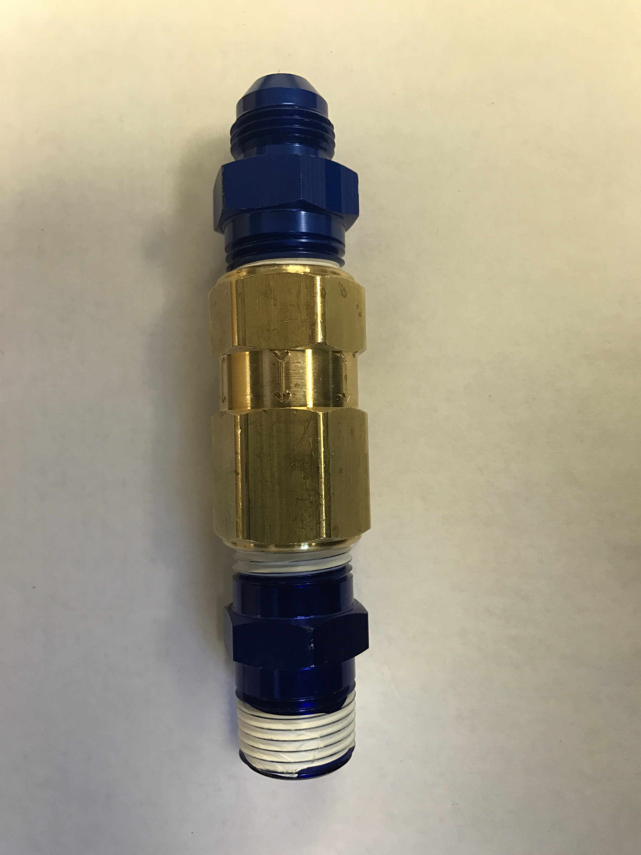
Page 3 of 4

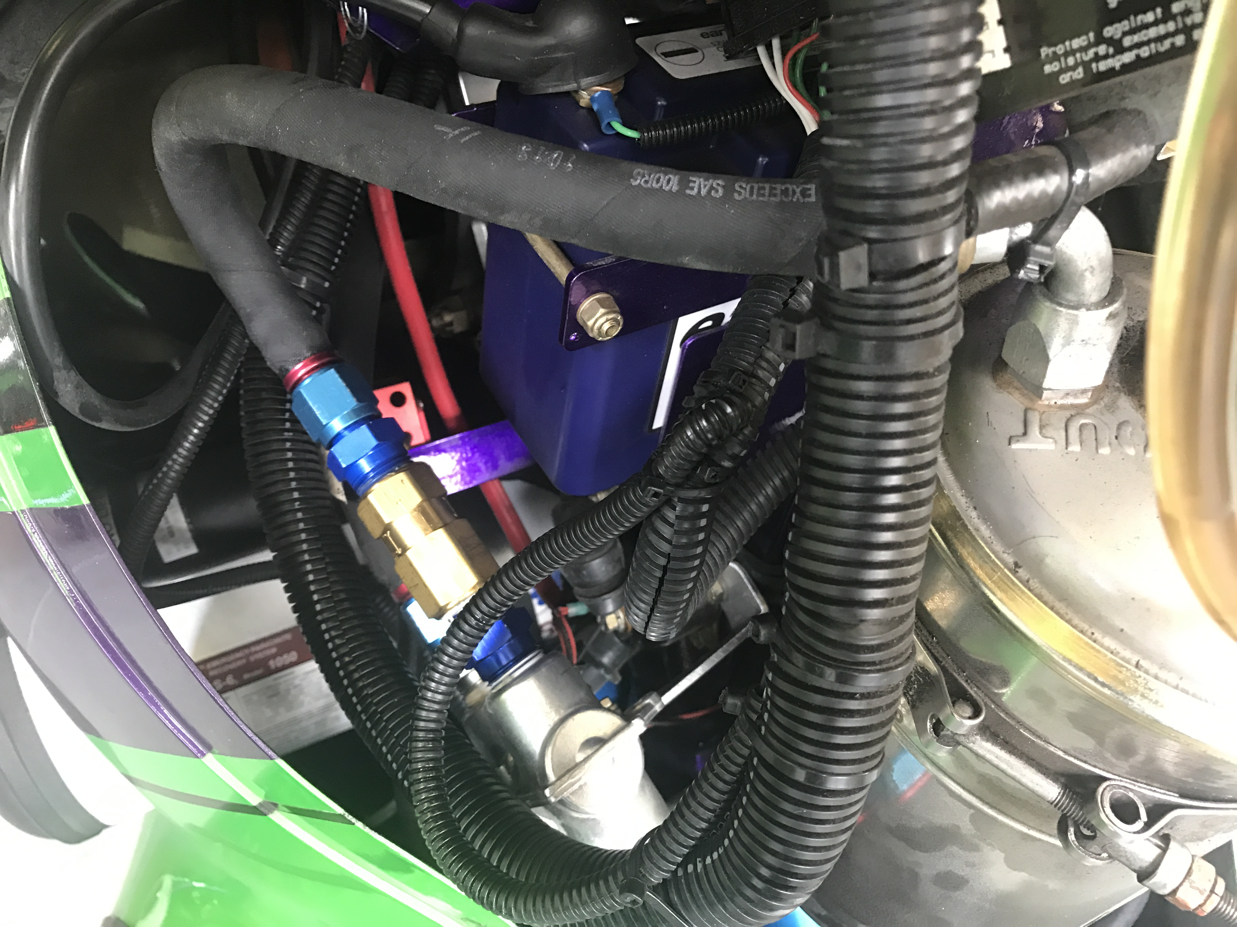
912ULS shown. 912iS has the oil thermostat mounted 12” lower.
Fitting (can be blue or chrome) on left is fitting previously in oil thermostat. Gold colored fitting in center is the oil check valve with the arrow pointing to the right (showing direction of flow) and the blue fitting on the right is the male/male adaptor.
TESTING:
- Start the engine and verify the oil pressure comes up to 40 PSI minimum within 5 seconds
LOGBOOK ENTRY:
Aircraft logbook should be marked with the following entry and dated and signed “SERVICE BULLETIN 0001” from the manufacturer satisfied as per instructions. Compliance with ASTM standards maintained.”

Page 4 of 4

